ASSIGNMENT 4

1)

CODE:

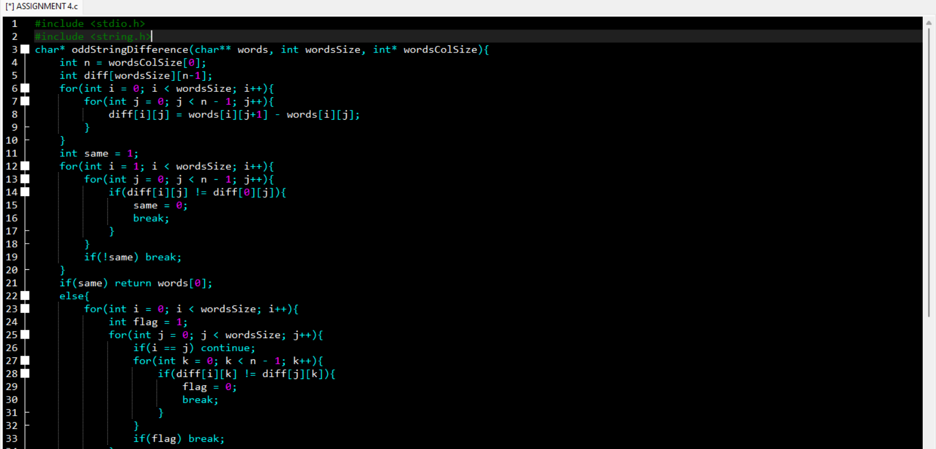

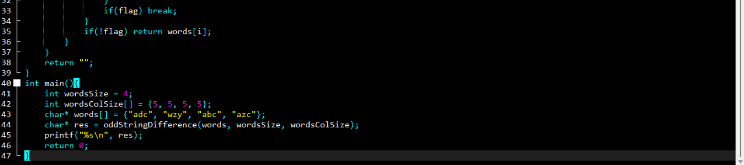

OUTPUT:

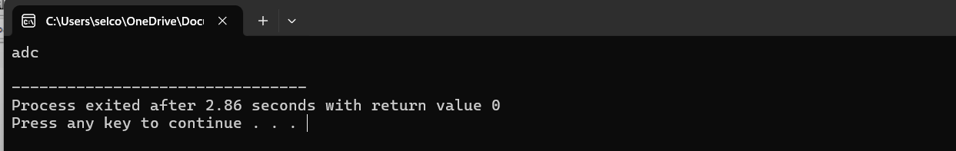

2)

CODE:

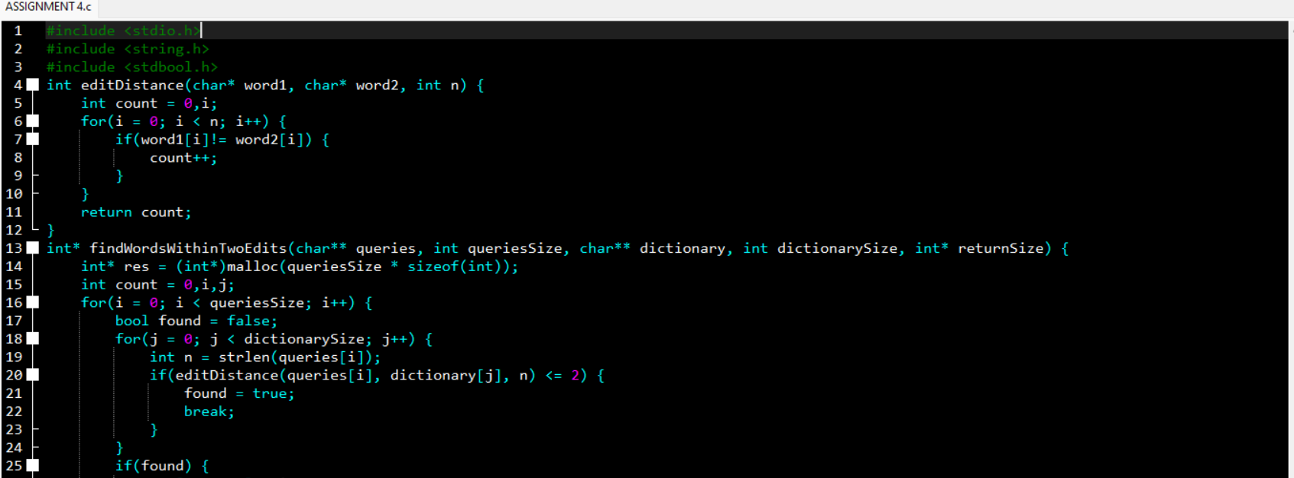

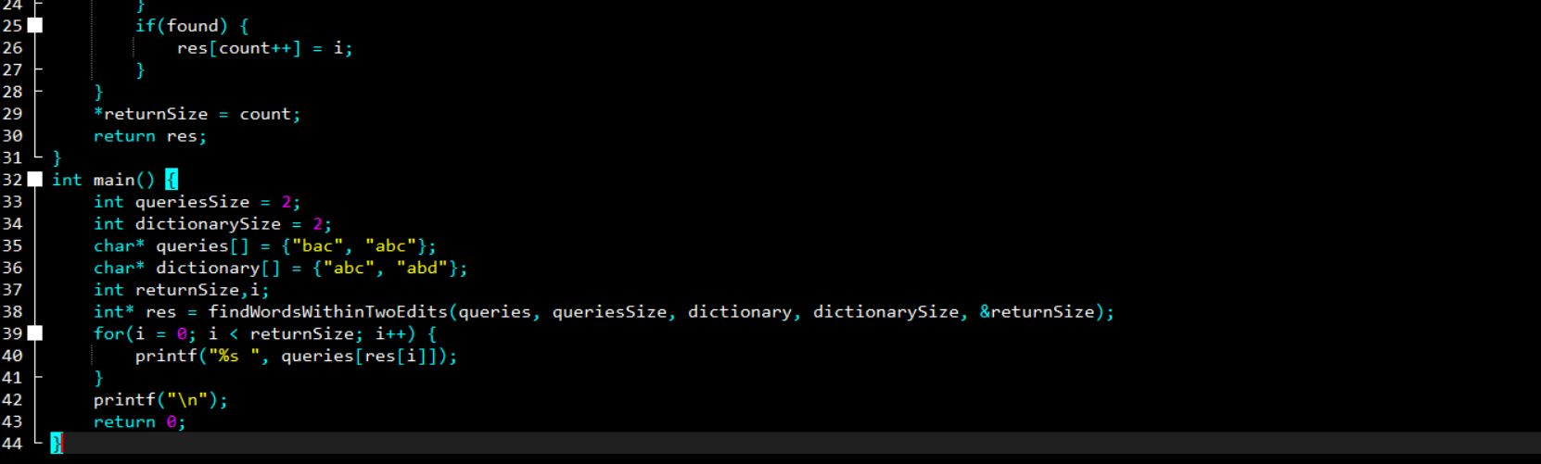

OUTPUT:

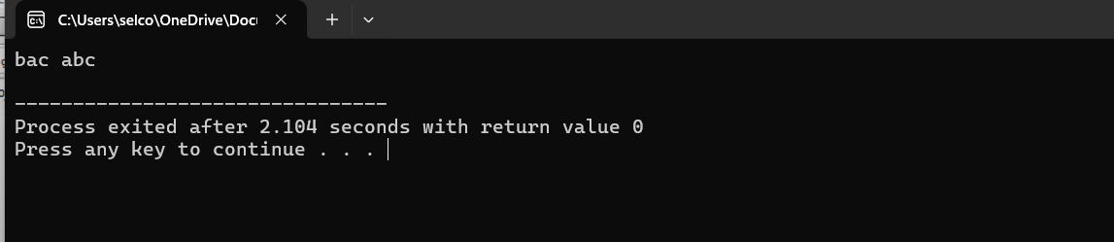

3)

CODE:

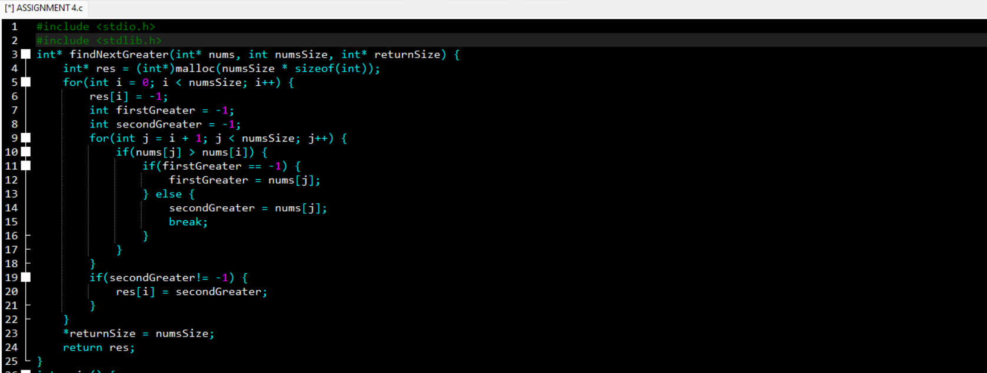

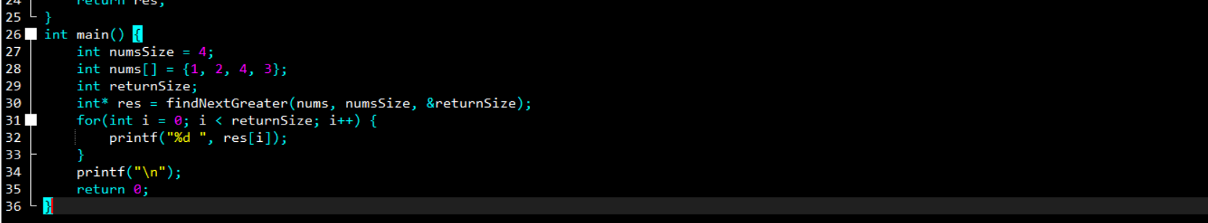

OUTPUT:

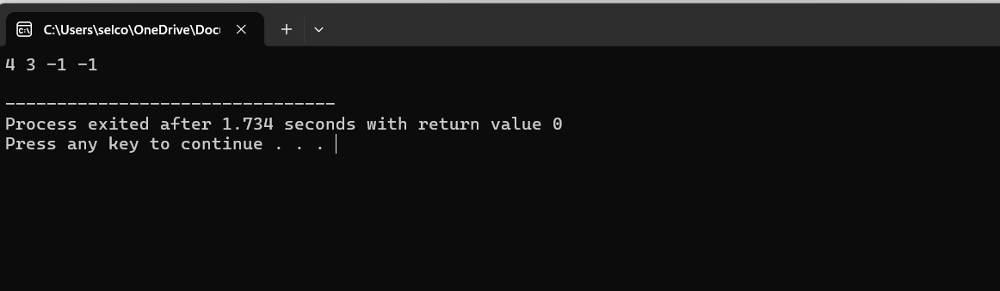

4)

CODE:

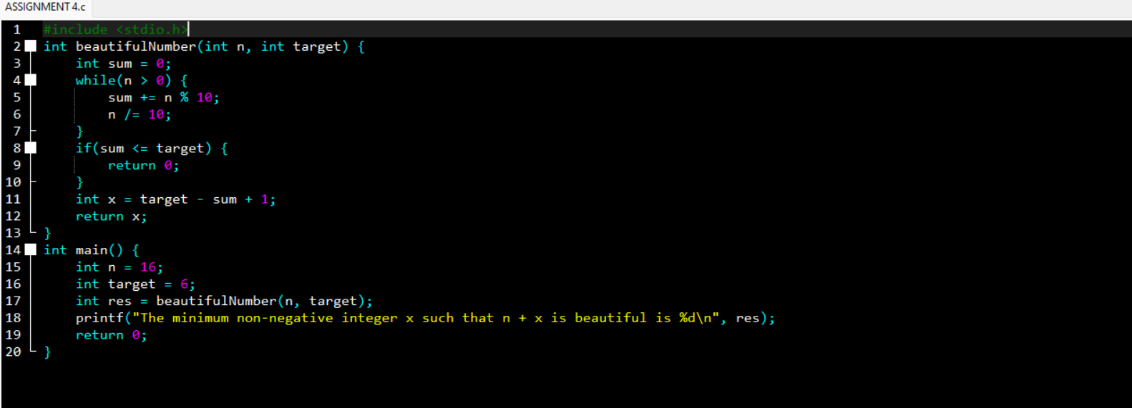

OUTPUT:

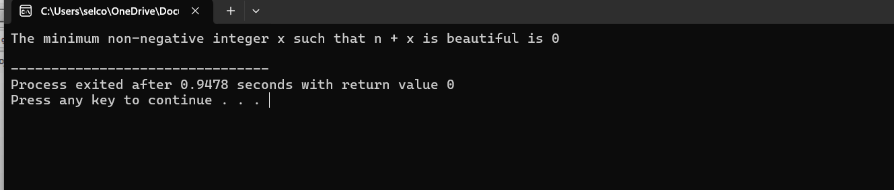

5)

CODE:

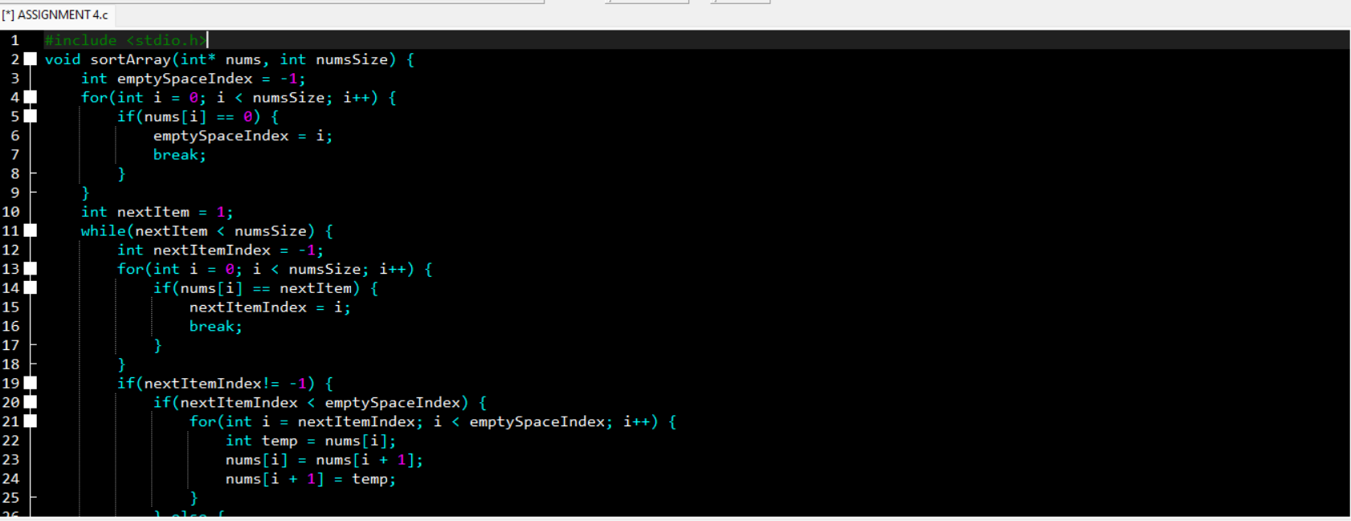

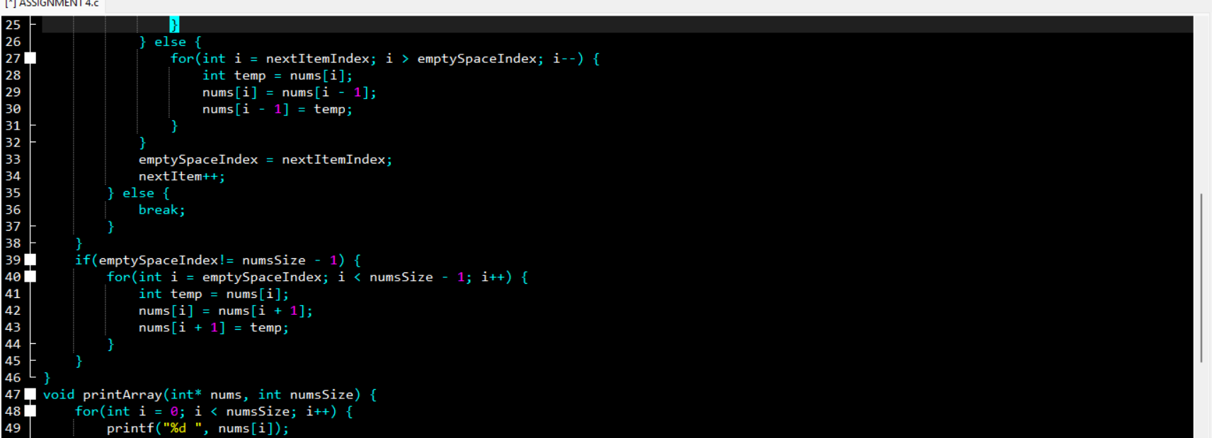

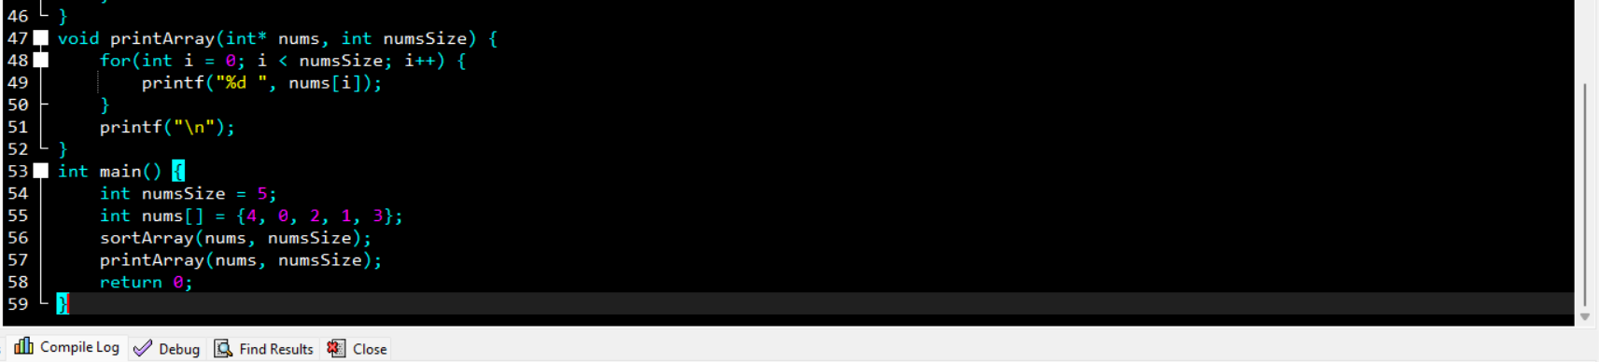

OUTPUT:

